# Exercise 4.2.2 page 183

Hvornår kan vi slå dem sammen?

When there is exactly one Studios and exactly one President, we can combine the two entity sets into a single entity.



# 4.2.3

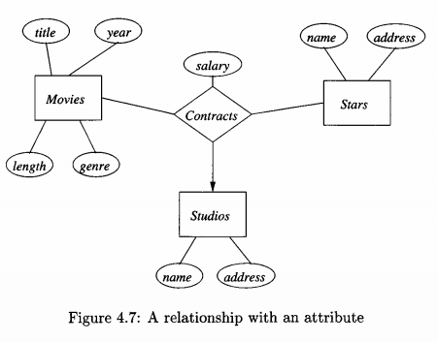

# 4.2.4 figur 4.13)

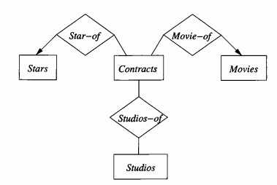

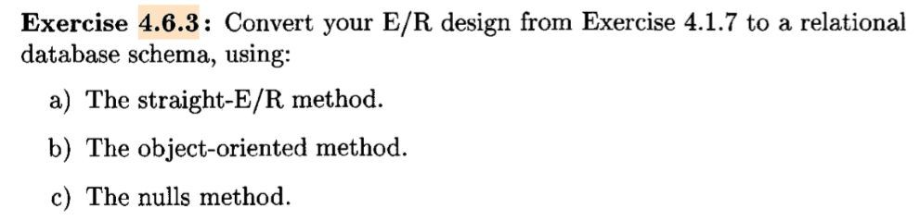

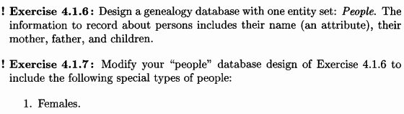



IsA til alle 3 og lav dem om til database schemas.

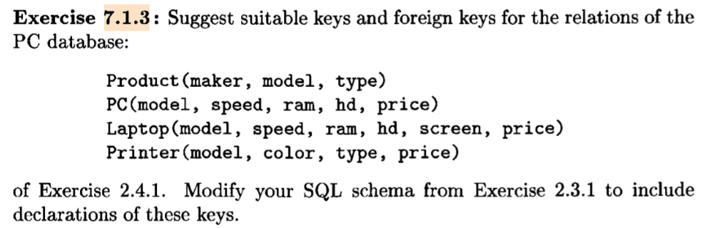

Model is a PK in each table and FK from Product to all other tables, it’s unique and they are linked through it. Product(type) only states if it’s printer/PC/laptop. Printer(type) has nothing to do with it and there are no two the same models of different type in printers.

# Exercise 7.2.2

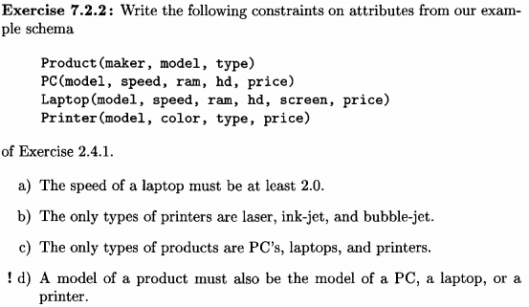

a)

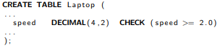

b)

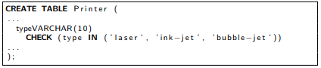

c)

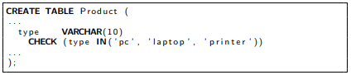

d)

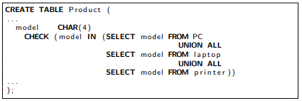

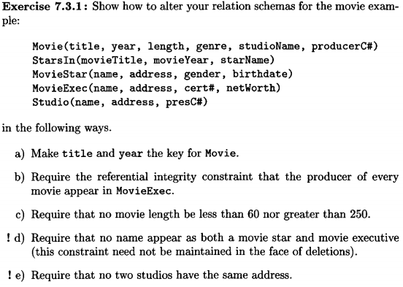

|  |
| --- |
| a) |
|  | ALTER TABLE Movie |
|  | ADD PRIMARY KEY (title, year); |
|  |  |
|  | b) |
|  | ALTER TABLE movie |
|  | ADD CONSTRAINT FK_Producer |
|  | FOREIGN KEY (producerC#) REFERENCES MovieExec(cert#); |
|  |  |
|  | c) |
|  | ALTER TABLE Movie |
|  | ADD CONSTRAINT CHK_length |
|  | CHECK (length >=60 OR length <= 250) |
|  |  |
|  | d) |
|  | ALTER TABLE MovieStar  ADD CONSTRAINT noExecutive  CHECK (name NOT IN (Select name from movieExec)) |
|  | ALTER TABLE MovieExec  ADD CONSTRAINT noMovieStar  CHECK (name NOT IN (Select name from movieStar)) |
|  | e) |
|  | ALTER TABLE Studio |
|  | ADD CONSTRAINT UC_address |
|  | UNIQUE (address); |

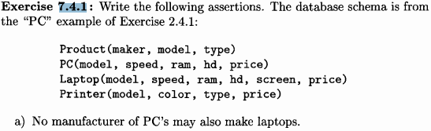 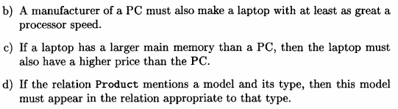

An assertion is a boolean-valued SQL expression that must be true at all times

a)

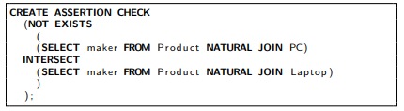

b)

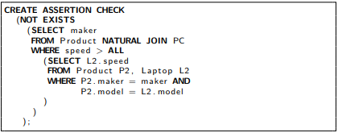

c)

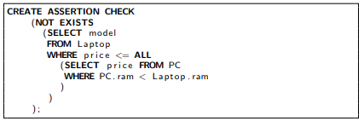

d)

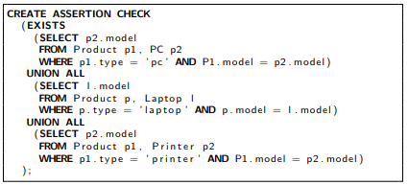

# Exercise 7.5.2

